Lim, Francis Raemark L.

Monoso, Jose Miguel

Code:

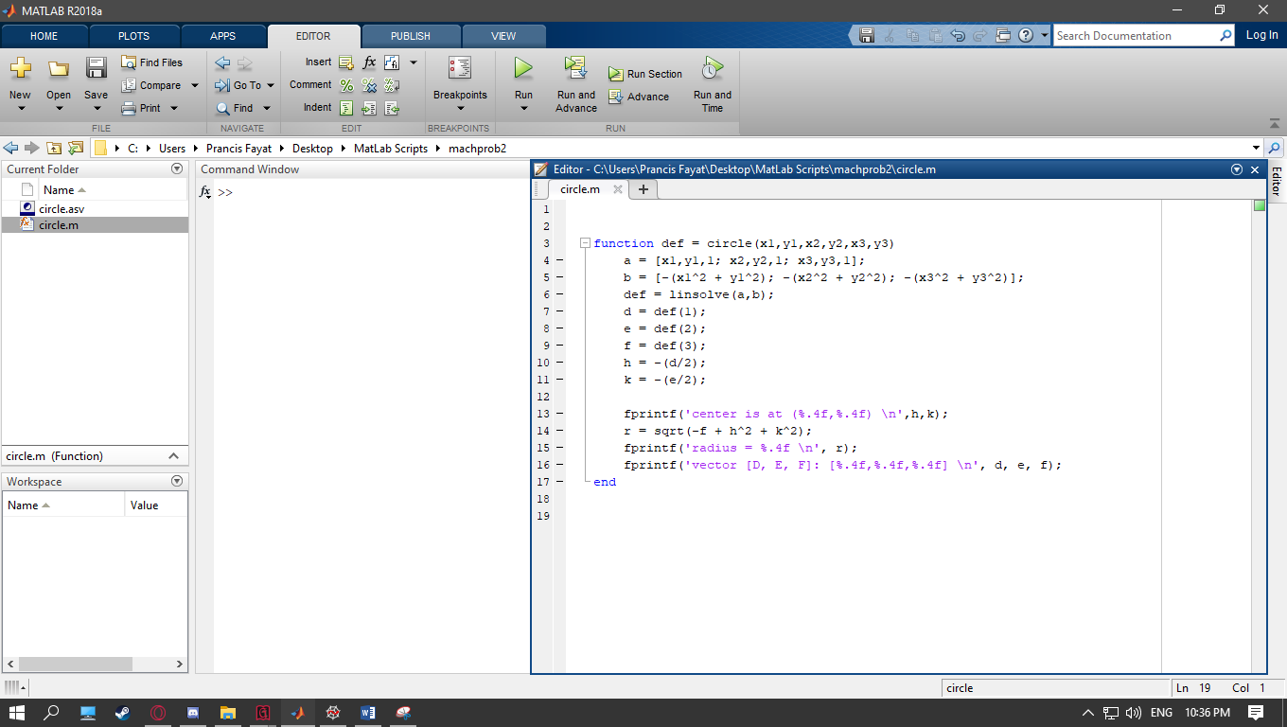

Testing:

Given points (2,5), (3,-2), (-6,1)

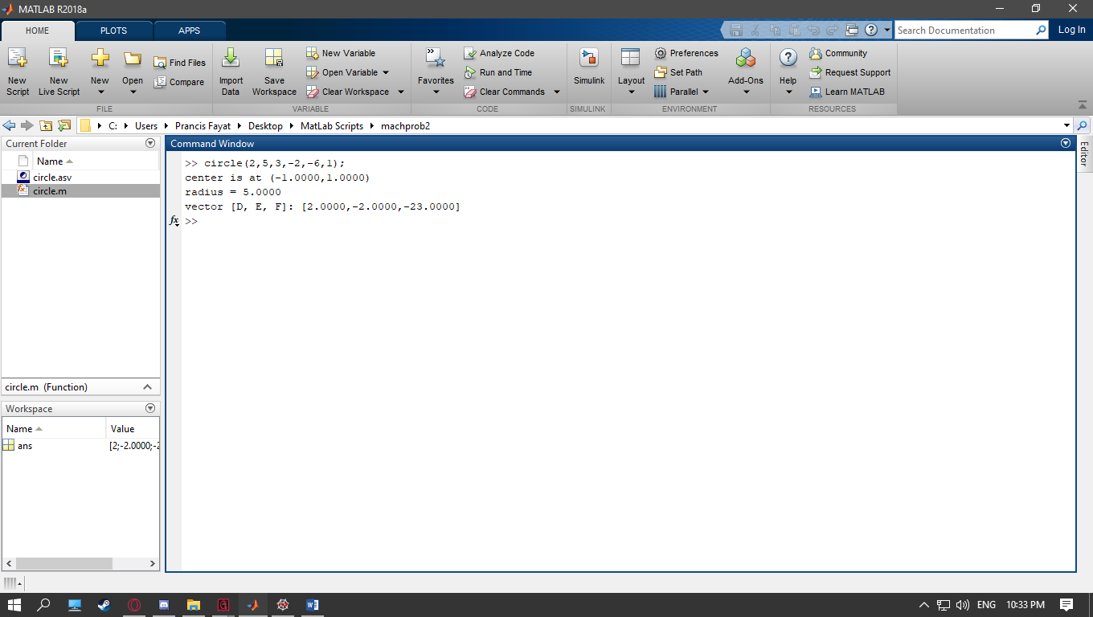

Proof using desmos graphing calculator:

From vector [D, E, F], the general equation is x^2 + y^2 + 2x – 2y – 23 = 0

